Addition and Subtraction Strategies- A quick guide for parents
These are some of the Maths strategies your child has been introduced to so far this year. I believe it is beneficial for students to try a variety of strategies so they can discover what works best for them and their thinking. Some of these, they will like better than others.
The Secret Code- is a special name for a list of strategies that students can use to connect numbers easily.
These strategies include; count on and count back (e.g. 9 count on 3 is 12 and 9 count back 3 is 6), doubles (e.g. 6+6) and near doubles e.g. (6+5), Rainbow Facts (Numbers that go together to make 10 e.g. 1 and 9, 2 and 8 etc), Friendly numbers (end in a 0 and are easier to add and subtract from e.g. 10, 20, 30) and Landmark numbers (numbers that are significant/easy to work with and relate to other concepts such as percentages e.g. 25, 50, 75, 100)
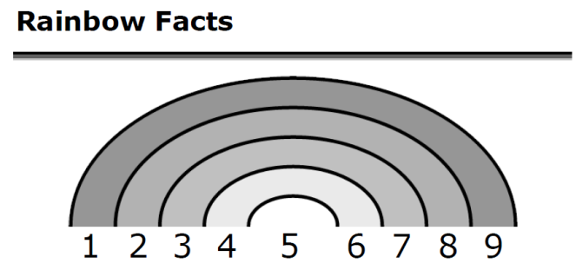
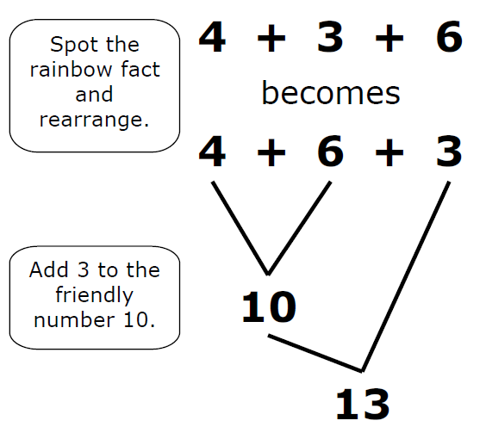

Splitting and chunking for addition- Number splitting can help you add numbers quickly. First split both numbers into their place value and then add the chunks.
e.g. 47+36
Split the 47 into 40 and 7 and the 36 into 30 and 6. This is the correct place value. Then chunk as below. The letters stand for the secret code strategies used. They can be omitted once students are familiar with this process.
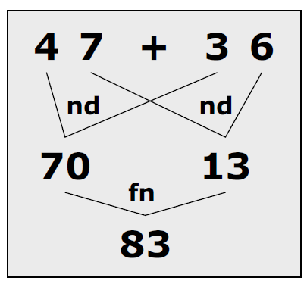

Front end addition- Similar to the traditional algorithm method, except student start from left to right (e.g. tens then units) and use digits in their correct place value.
e.g. 36
+47
_______
30+40= 70
6+7= 13
________
70+13=83

Addition on a number line- An empty number line is a line with numbers marked to show mathematical operations like addition and subtraction. It has no starting number and no scale on the line. It works from left to right for addition. This enables students to put the information they need on the number line.
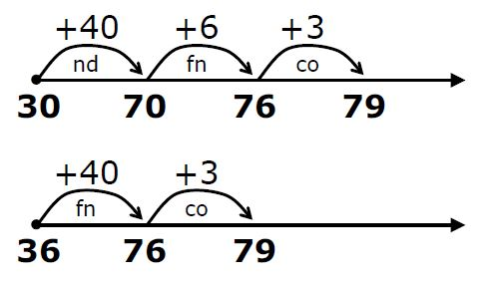
For example 36+43 can be done in many ways;

Subtraction on a number line- Same as addition but we work from right to left and subtract numbers.
e.g. 65-36- split the 36 into parts to make it easier to take away from 65
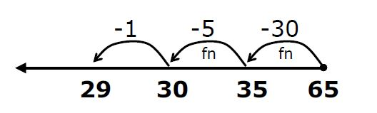

Three digit subtraction- Number splitting can help with subtracting three digit numbers.
254
-136
_________
Start with the whole top number and subtract the bottom number in place value starting from left to right (hundreds first). Keep a running total as you go.
254-100= 154
154-30= 124
124-6=118

Find the difference- Finding the difference means finding the gap between 2 numbers. You can add or subtract to find the difference.
Add=count on Start with the smallest number on the left and count on to the larger number on the right of the number line. Then count the value of the jumps.
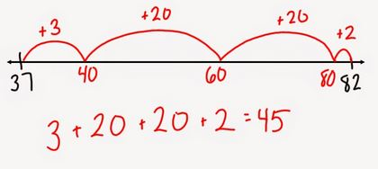
e.g. Find the difference between 37 and 82

Subtract=count back Start with the largest number on the right and count back to the smaller number on the left. Then count the value of the jumps.

