Multiplication Facts
Parents frequently ask us whether we believe children should learn their multiplication tables and our answer is a resounding yes — but rote learning should not be the first step in the process.

Research suggests that many students do not actually make links with multiplication as they parrot their tables with a result that they don‘t actually know what 6 times 7 actually means.

We introduced tallies as a visual strategy for working out multiplication facts. For 6 × 6 for instance we can see in the illustration below how knowing 6 × 5 helps know 6 × 6.
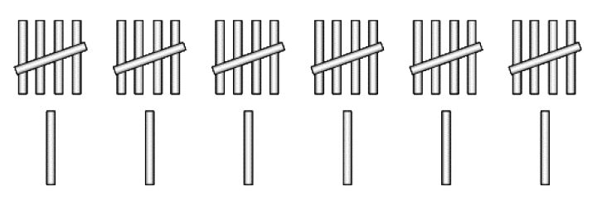

Most children either know or can quickly work out their 5s facts so building up or down from there is a strategy that works well for them. It is cumbersome though to actually have to draw tallies to work out multiplication facts.

Recently in a classroom a girl who seriously struggles with maths invented the following strategy because she didn‘t want to have to draw all of the tallies every time. Her strategy for 6 × 7 is shown below as she drew it
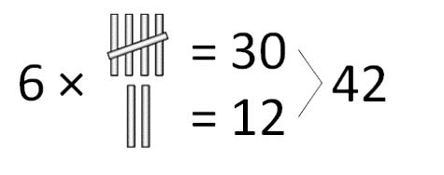

Her comment was, ―I know my 5s and I can double any number so this works for me‖ It was soon working for many of her peers too. Many children will be using methods like these in their heads to quickly construct the answers to multiplication facts. What do we know from brain research? That when the pressure is off the brain works better. For many children knowing how to construct their multiplication facts with understanding soon results in instant recall.
There is a sequence used in most classrooms for helping children master their tables;

2x- The sequence usually begins with the 2s as most children learn to skip count in 2s and to double numbers quite quickly.
4x- Knowing the 2s helps with knowing the 4s. Teachers often a call this double doubles. How do you work out 8 × 2? If you know the double for 4 × 2 you can double it again to find 8 × 2.

8x- The doubling process is used again later for the 8s table.

10x- The 10s is easy to learn particularly as children often learn to count in 10s as part of the skip-counting process.

5x- Making links between the 10s and the 5s is a common next step. Children can count in 5s and have often already had many experiences with counting tallies in 5s. They can see the links between 3 × 10 and 6 × 5 and other related 5s and 10s facts. They can investigate the patterns in the 5s counting pattern and understand that any number in the 5s table will end in 0 or 5.

3x- After this teachers generally teach the 3s table

6x- … and use doubling to link the 3s table to the 6s table.

9x- There are lots of tricks for the 9s. But understanding does not develop from using the hands as a tool. Rather it comes from thinking about how close 9 is to 10 (to work out 6 × 9 think 60 and subtract 6). Tallies are the ideal way of making this visible to children.

7x- What about the 7s I hear you ask. Well let‘s look at that!
1 × 7 easy
2 × 7 a simple double
4 × 7 a double, double
8 × 7 double again (or think of the sequence 5 6 7 8 and you‘ve said it!)
9 × 7 derived from knowing 10 × 7.
What is left?
3 × 7. Well that is the turnaround of 7 × 3 or easily found by adding double 7 and 7.
7 × 7 is a square number —once I was told that as a child it has stuck in my memory forever.

With this understanding in place some rote learning may be beneficial if it is needed at all.

